**Linux final project**

**1. The Windows clients should receive IP address, default gateway**

**address and DNS server IP address automatically from the DHCP server.**

Change the hostname for both servers to server 15 and server 16

For server15

For server 16:

download the DHCP package (do the following steps for server 15)

Make sure the connection is set to automatic.

configure the dhcp config file through **/etc/dhcp/dhcpd.conf**



Make sure to restart the dhcpd service



Start the dhcp service:

Verify the status of the dhcp service:

**Getting the info from the dhcp server to windows client**

1. Open the windows 10 virtual machine

1. Open the start menu and enter control panel:

1. After clicking on control panel select “network and sharing center”

1. Click on change adapter setting on the left



1. Right click on the network adapter you want to configure and select properties

1. In the ethernet properties dialog box select internet protocol version 4(TCP/IPv4) and click properties button

1. In the Internet protocol version 4 (TCP/IPv4 ) properties box select obtain an ip address automatically and obtain address automatically radio buttons

1. Now in windows client insert ipconfig

If the ipconfig worked next step is look at the leases located at **/var/lib/dhcpd/dhcpd.leases**

Once the windows dhcp part is configured its time for the other server to receive it as well (server16)

Setup dhcp for server 16

1. Edit the config file /etc/sysconfig/network-scripts/ifcfg-interfacename
2. Add the line BOOTPROTO=dhcp

1. Restart the network service

1. Check if it got an ip address from the dhcp server: A screenshot of a computer

   Description automatically generated with low confidence

5. check the leases if it got updated with server16

PINGING each server

Server 16 to server 15

Server 15 to 16

Windows to server 15

If you close application and restart and have trouble, use this for Linux server:

Will remove and give a new Ip address

**Question 2: The windows client should be able to resolve the name and Ip address of both servers.**

1. **Install the dns server package (bind)**

**2. Mount the DNS iso file to virtual box:**

**3. Make sure to unmount anything that was previously mounted**

**4. Create directories for the mounting process**

**5. Mount the file to the directory:**



**6. show the contents of the directory using ls**

**7. Make sure to save a copy of the original file just in case**



**8. Copy the files from the template and set in the right directories + use ls to show:**

**9. Setting Permissions for all three files:**

**10. Editing the config files for named.conf**



**11. Editing abc.loc.forward file**

**12. Editing the abc.loc.reverse**



**13. Testing dns configuration and zone files**

**14. Making sure the dns configuration file has the right data:**

**15. Verifying the dns config file in resolv.conf**

**16. Verifying Dns config file in hosts**

**17. Make sure to restart the network**



**18. Checking the status of the server:**

**19. Starting dns service**

**20. Configure the firewall to trust other host/networks**

**21. Use nslookup to see the servers:**

**Question 3: Any user logged to a Windows client should be able to access the web**

**server:** [**http://www.abc.com**](http://www.abc.com)

1. **Open the /var/named/abc.loc.forward file.**



1. **Find the ip address of the site:**



1. **Enter the found ip address in the config file**

**4. Restart the dns server:**



**5. Go on windows side and use ipconfig /flushdns to remove the dns cache**



**Question 8: Only the members of the group admins should be able to log with ssh to the two linux server from any host on the local network**

1. **Make sure ssh is installed on both linux servers (server15 – server16)**

**2. Start ssh service on both machines:**

**3. Ping the two computers**

From server 15 to server 16

From server 16 to server 15

**4. Creating a group called admin**





**5. Creating specific user**

**6. Adding the user to the group:**

**7. Edit the config file to restrict**

Make sure to remove the comment and put yes to no for permit root logins

Make sure to also allow groups for Admin



**8. Make sure you restart the service:**

**9. Connect via the managers user:**

**10. If you are not part of the admin group you cannot access:**

1. **Write a script that:**

**A). Save the DHCP information (the clients that got IP from the server) locally on server 15**

**1. Create the script.**



**2. Write config in the file**

**3. Create a directory for storing and run the command “./ dhcp_script.sh”**

3.1Create directory to store the leaseLocation

3.2 Find the location to use in the script.

3.3 After configuring the script run the script

3.4 Go into the directory and list the contents.

3.5Cat the contents

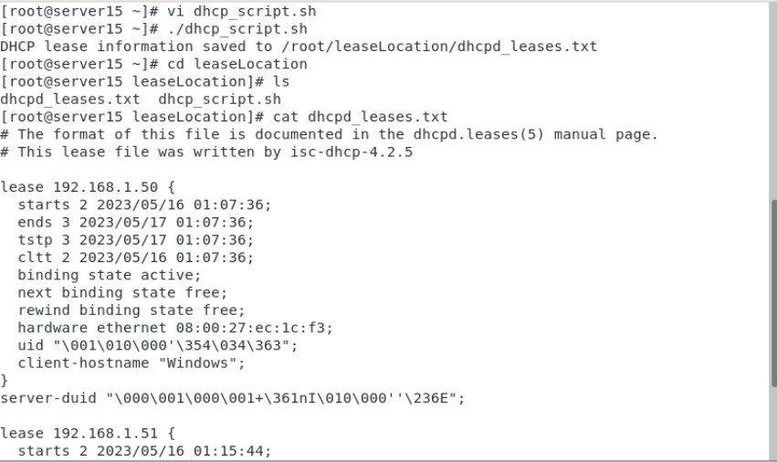

**B) And send this information each hour to you by email.**

**1. you need to download mailx**



**2. Enter the configuration for the email in the file:**

**3. Add a cron job to specifiy when to send the files**



To make it every hour include this line

